

**SMT201 - Geographical Information Systems for Urban Planning**

**AY 2023/2024 Semester 1**

**Project Report**

**Post-Flood Accessibility Analysis**

| **Student Name** | **Student ID** |
| --- | --- |
| Han Wen Yu May | 01456997 |
| Hazyra Binte Mohamed Surani | 01417331 |
| Tan Wei Ping | 01418426 |

# 1 GIS Analysis Process and Functions Used

In our project, we made use of both vector and raster data. Raster data was used to understand where the majority of the population resides and compared to how the flood extent badly affected the residents living in the area.

Most of the maps generated involved vector data. The processes we used include built-in functions of QGIS, mainly Geoprocessing Tools (Clipping, Difference), and Research Tools (Select by location). Furthermore, external plugins from QNEAT3 were used to carry out accessibility analysis. This allowed us to calculate the distances between the various start points (flood disaster services) and different parts of Derna and Libya. The plugin also allowed us to consider the factors of speed and distance, and real-world conditions of an area impacted by flood.

A detailed step-by-step of our project can be found on under [Reproducible Steps (Methodology)](https://docs.google.com/document/d/1XIvwmiX4T_MgXvOSWEAo7rUCrC8MFN13FIDXy5ja058/edit?usp=sharing)

# **2 Collection of Maps + Discussion of Analysis Results**

The maps we produced aim to provide an overview of the overall accessibility of services that residents in Libya have when met with adverse flood conditions. We aimed to take different stakeholders (i.e. residents, emergency service team) into account.

Map 1: Overview of Derna’s Population Density and Places of Interest

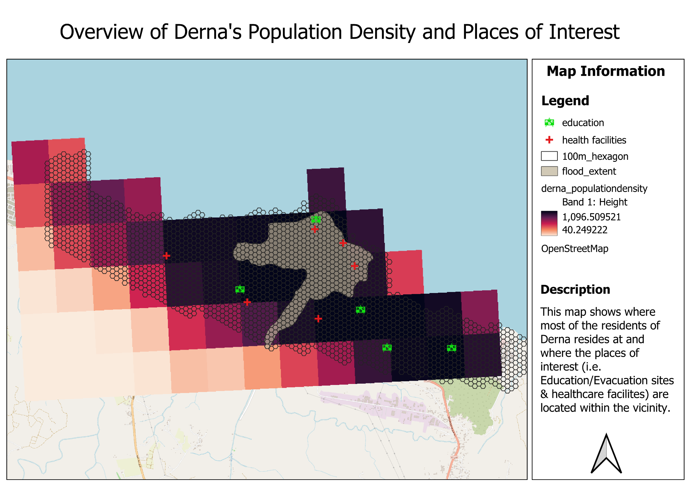

Research has shown that the flood was triggered by torrential rainfall that resulted from the catastrophic Storm Daniel. This has caused the collapse of 2 dams upstream of Derna to collapse, hence unleashing unprecedented amounts of water downstream to the populated city of Derna. As seen from the flood extent, the areas near the river, ‘Wadi Derna’, were the most affected and blocks of houses were swept away to the coast. This is exacerbated by the geography of Derna, which is low-lying and runs in the middle of the coastal city is a river. This increases the susceptibility to flooding in Derna.

Another factor of the increased vulnerability is the lack of quality infrastructure that can withstand adverse weather conditions. This goes back to the political instability of Derna, which has also contributed to little or no flood warning system in the country.

It is notable from the map that the areas around the Wadi Derna are the most populated areas in Derna, and that a majority of the population is concentrated in the central area. This is unsurprising because settlements tend to form around water bodies with the most resources.

Additionally, research shows that people tend to live near their job locations, and since the central area has the most resources/amenities (e.g. shopping malls) as compared to the outskirts of the city, it follows that the majority of the population would be concentrated near these facilities. That said, with a huge population, it is worrying that there are only a few bigger (i.e. hospitals, clinics) healthcare facilities located in the central area, with half of the facilities gathered near the coast, rather than spread out evenly across the central area.

As we can see from the map, there are 6 healthcare facilities and 5 evacuation sites. These evacuation sites are schools, even though we do not have existing capacity data, given the size of schools, they more likely have greater capacity to host a larger number of people. Worryingly, at least 3 hospitals fall inside the flood extent and this greatly reduced the amount of healthcare resources during a flood.

**Map 2: Accessibility of demand**

**2A Health facilities on vehicles**

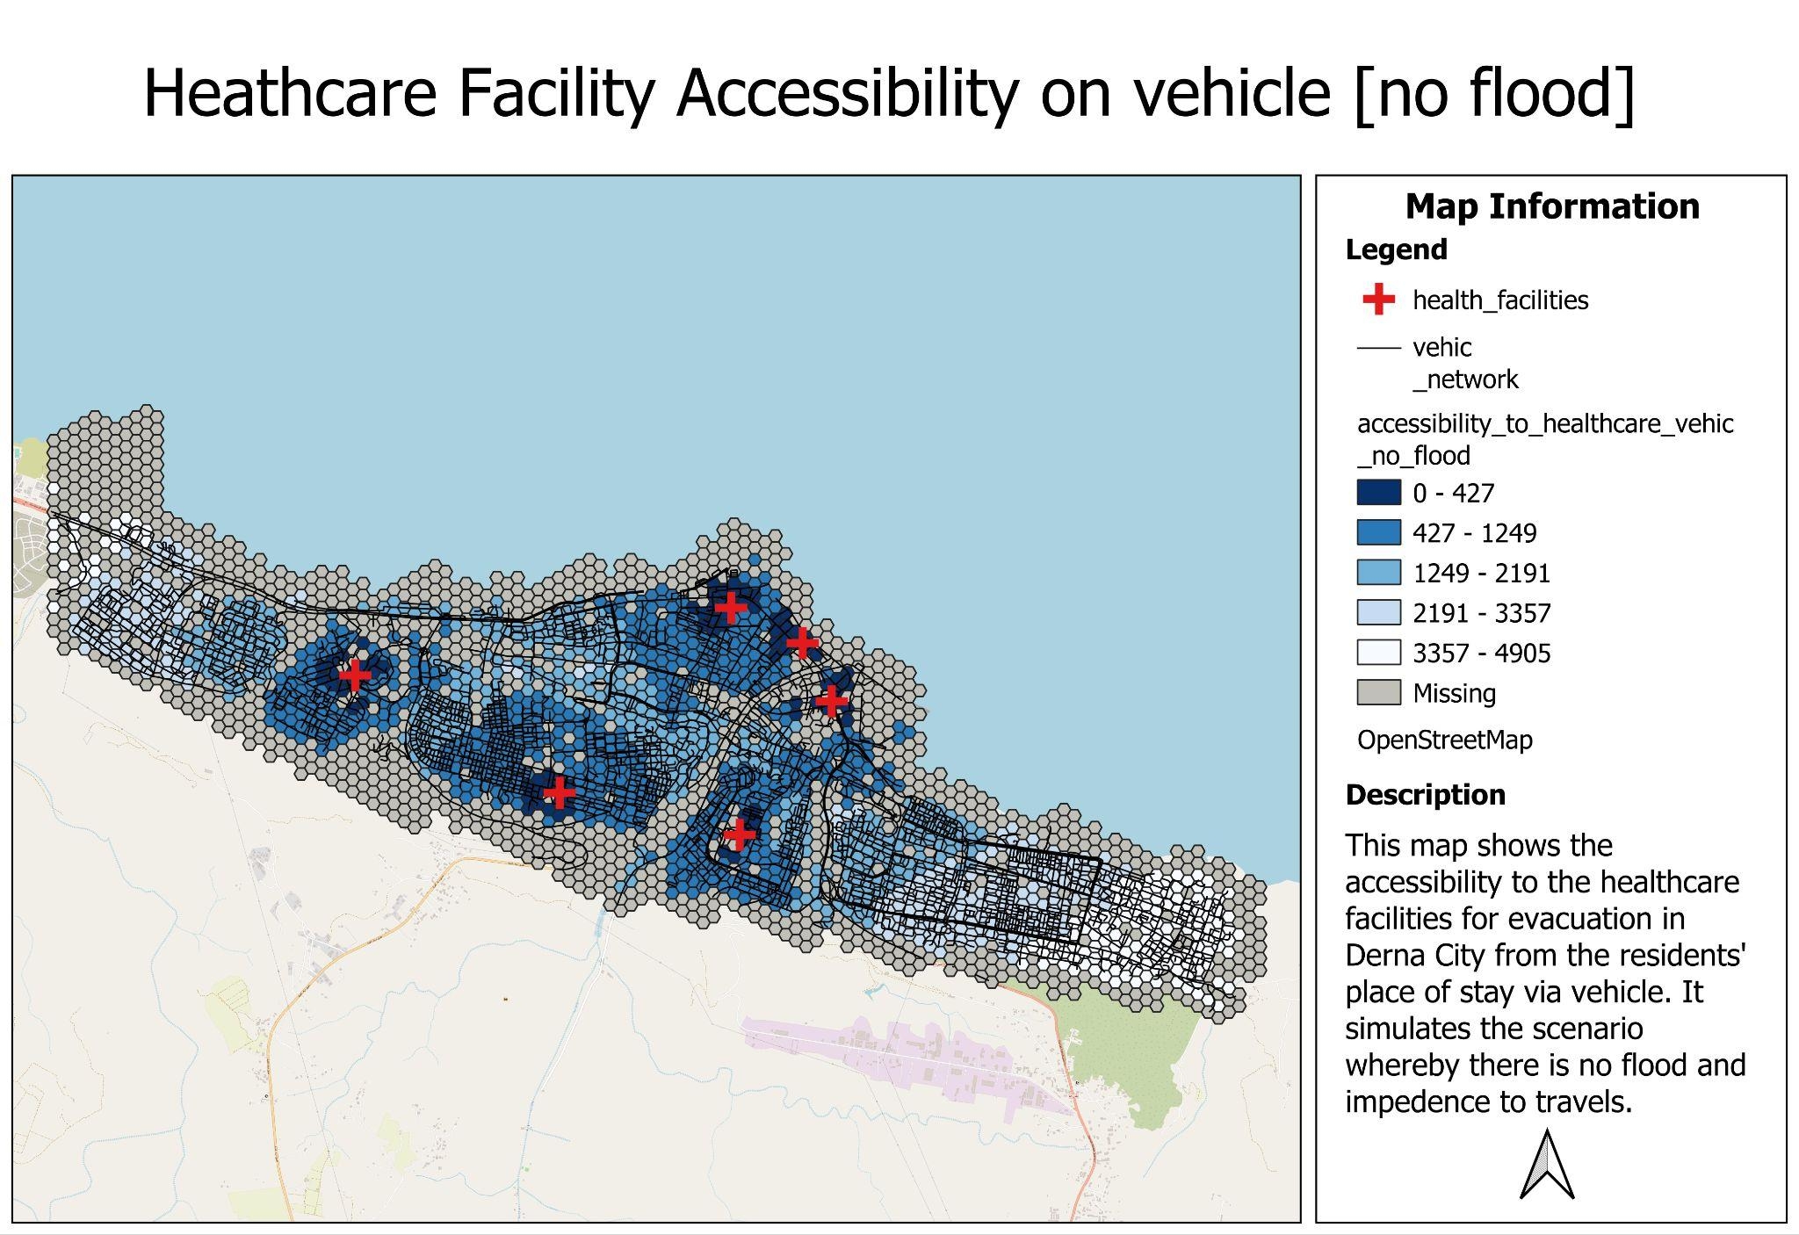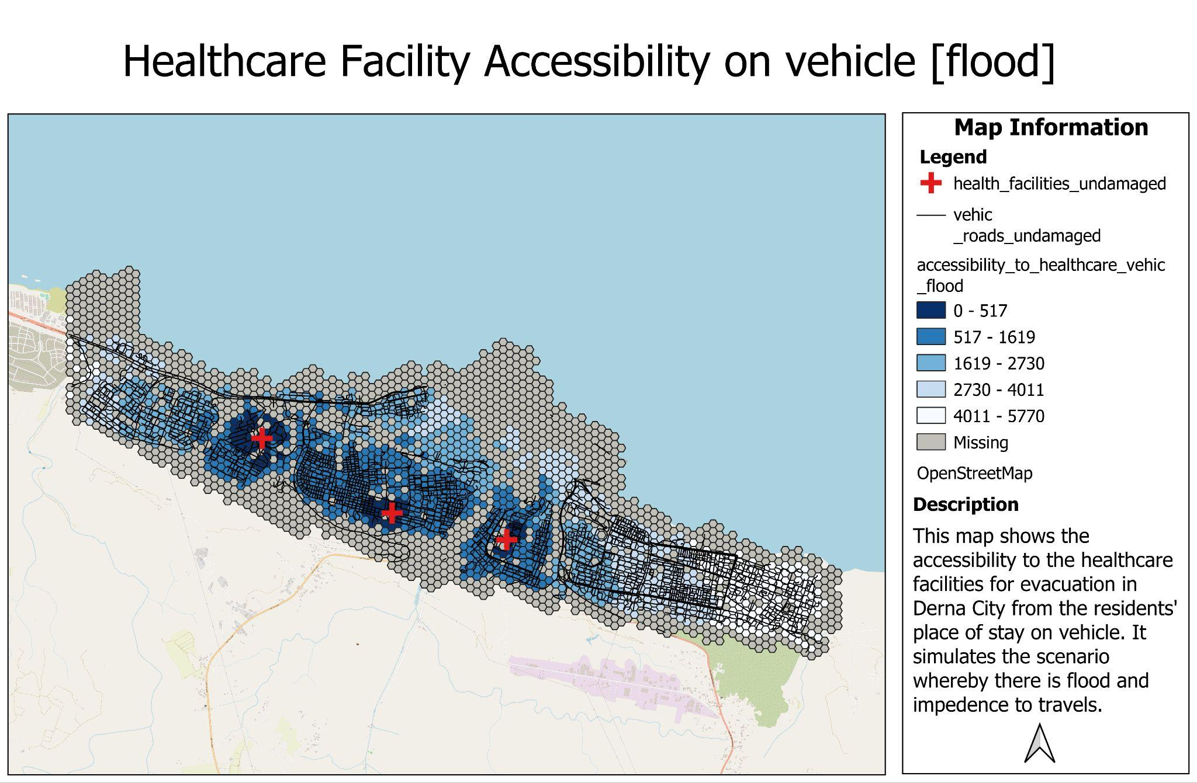

Assuming that the identified healthcare facilities are up and running, the vehicle access to healthcare facilities seems adequate in Derna city in a normal situation where there is no flood. When there are no exceptions to environmental conditions, people’s movements are not impeded and the hospitals are accessible for people who live near it. However, for those who live far away from the hospitals, they would need to use their vehicles to travel longer distances. Despite that, it is evident that the road connectivity is generally vast and connects every edge of the city well.

Comparing the pre-flood and post-flood situation, it is evident that the flood has resulted in great damage done to public infrastructure, namely the hospitals and roads. Hence, even though residents previously lived near a hospital and hence had high accessibility to it, they may now have very low accessibility to the 3 remaining healthcare services. This is especially for residents living near the coast as the damage done by the flood made the roads and 3 hospitals that fall within the flood extent inaccessible. This is reflected in the significant increase in the number of missing values and there is no formal road infrastructure for the residents to get to healthcare facilities when faced with injuries.

Furthermore, the distribution of hospitals is not even and is mainly concentrated at the central area. The residents living in the Eastern side of the city have low accessibility to healthcare even if they have the means of transport as they would need to travel greater distances to reach the remaining 3 hospitals. This may mean that should a flood take place at that side of the coast, the residents will not be able to seek medical attention fast enough. Based on the population density shown in map 1, there is a sizable part of the population whose needs are not taken care of. This might also mean that if floodwaters eventually spread to the Eastern part of the city, the hospital located right at the East of Wadi Derna may be overpopulated and unable to provide for such a huge volume of residents.

This situation reflects the need to have **more healthcare facilities that are spread evenly and away from the river bodies**. This is to ensure the availability of ample healthcare resources in order to cater to the victims who may need it in the situation where some facilities become inaccessible due to disasters like this.

**2B Health facilities on foot**

**No flood Flood**

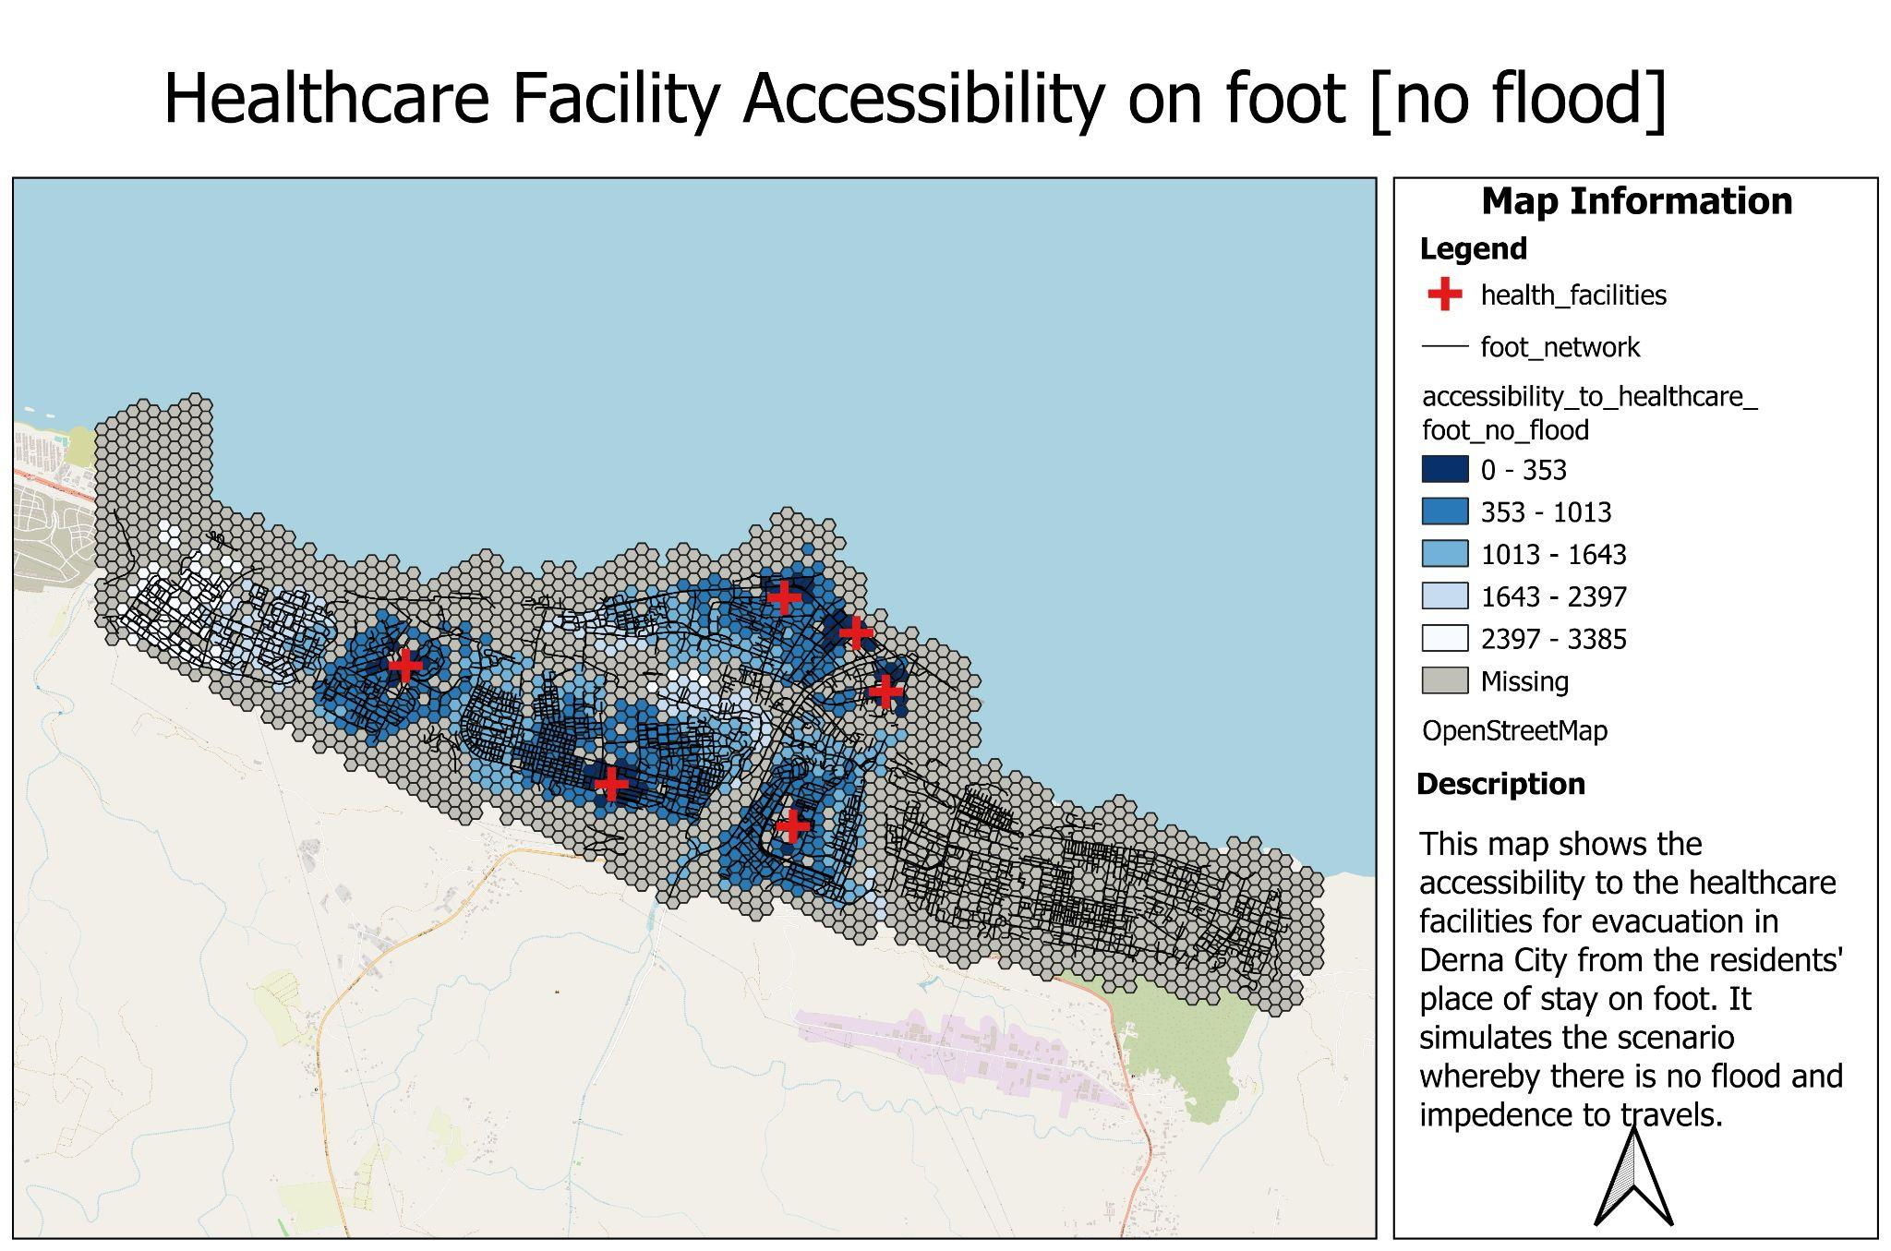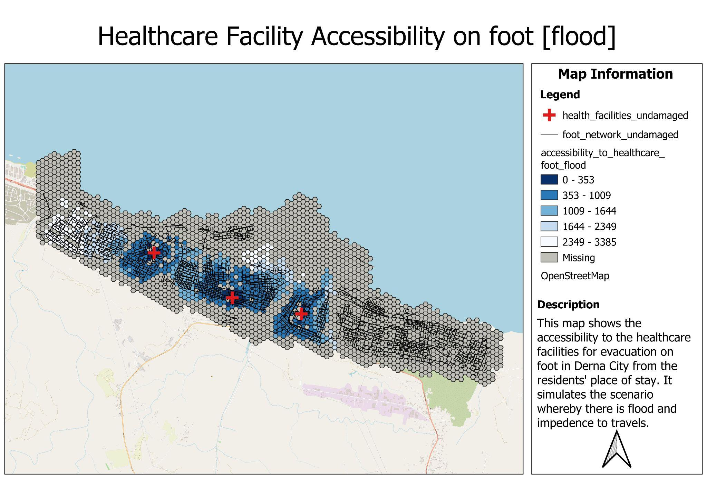

In the pre-flood situation, the accessibility to the healthcare facilities on foot shows a concerning phenomenon as even when there is no flood and impedance to the movement of people in Derna city, the healthcare facilities remain inaccessible. This is because there are a lot of roads that are not suitable for pedestrians to walk on and passing through these roads might be dangerous for the pedestrians and drivers who would need to keep a lookout for pedestrians who might just walk on roads that are not meant for them. This is especially prevalent in the eastern side of Derna city where the citizens do not have accessible and safe pathways to navigate to the healthcare facilities like hospitals and clinics should they need to as they are mainly concentrated in the central area that surrounds Wadi Derna. For the people who stay near the respective healthcare facilities, they seem to face no issue and there are ample roads that are suitable for them to navigate their way. This implies that there is accessibility inequality whereby people living in the East do not have ample pedestrian roads suitable for them to access the nearby healthcare facilities safely.

Simulation of the flooding tragedy in Derna city was done by removing the healthcare facilities and roads that fall within the boundaries of the flood extent. The flood has resulted in at least 3 healthcare facilities not being available for victims to get the medication they require should they need to. This is because it has been submerged in the flood.

Given that the amount of roads available for humans on foot is lesser than roads for vehicular travel, it is no surprise that victims are faced with an even greater challenge in trying to get healthcare facilities in the post-flood situation. This is especially so for those living in the far East as there are basically no healthcare facilities available for them and they will need to travel great distances to the central area.

While the accessibility to the remaining healthcare facilities remain accessible for victims living near it, it is expected that there will be an over-demand of victims who may need to compete for the limited resources in the remaining healthcare facilities. There are political complications that has impeded on the medical aid the people of Derna city needed (BBC, 2023). Therefore, there must at least have **more healthcare facilities to cater to future outbreaks of natural or manmade disasters**. This is to ensure that the people are self-sufficient and could help each other get the medical supplies with the help of existing medical staff support in these healthcare facilities, even when there is a lack of external medical support.

**Vehicle VS On Foot**

Comparing between the accessibility between roads that available for vehicular and on foot travels to the healthcare facilities, we can clearly see that there are more roads available for vehicles. Realistically in a flood evacuation, we won’t expect everyone to have vehicles to access healthcare resources especially when Derna City is in a developing country.

Therefore, there should be **changes to the existing roads infrastructure to open up alternative routes that are suitable for both humans and vehicular movements**. This will definitely be a long-term pursuit but it has to be implemented to accommodate to the needs for both groups of users.

**2C Education on vehicle**

**No flood Flood**

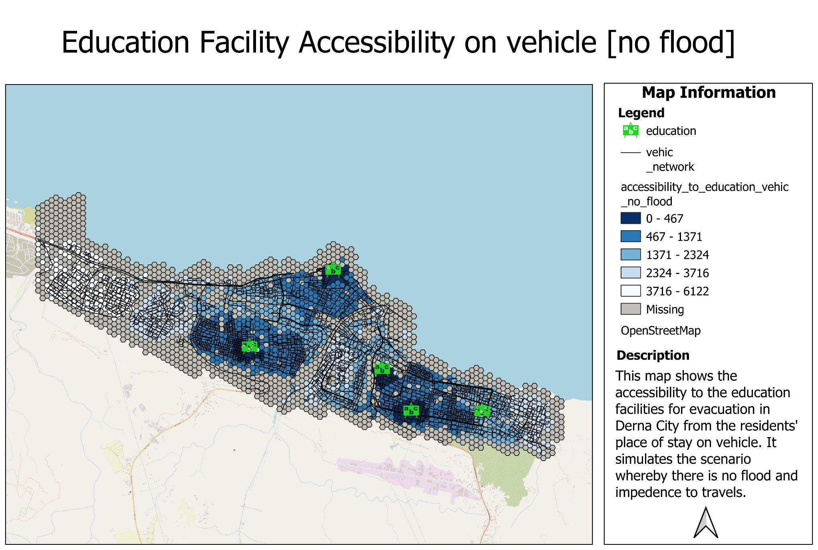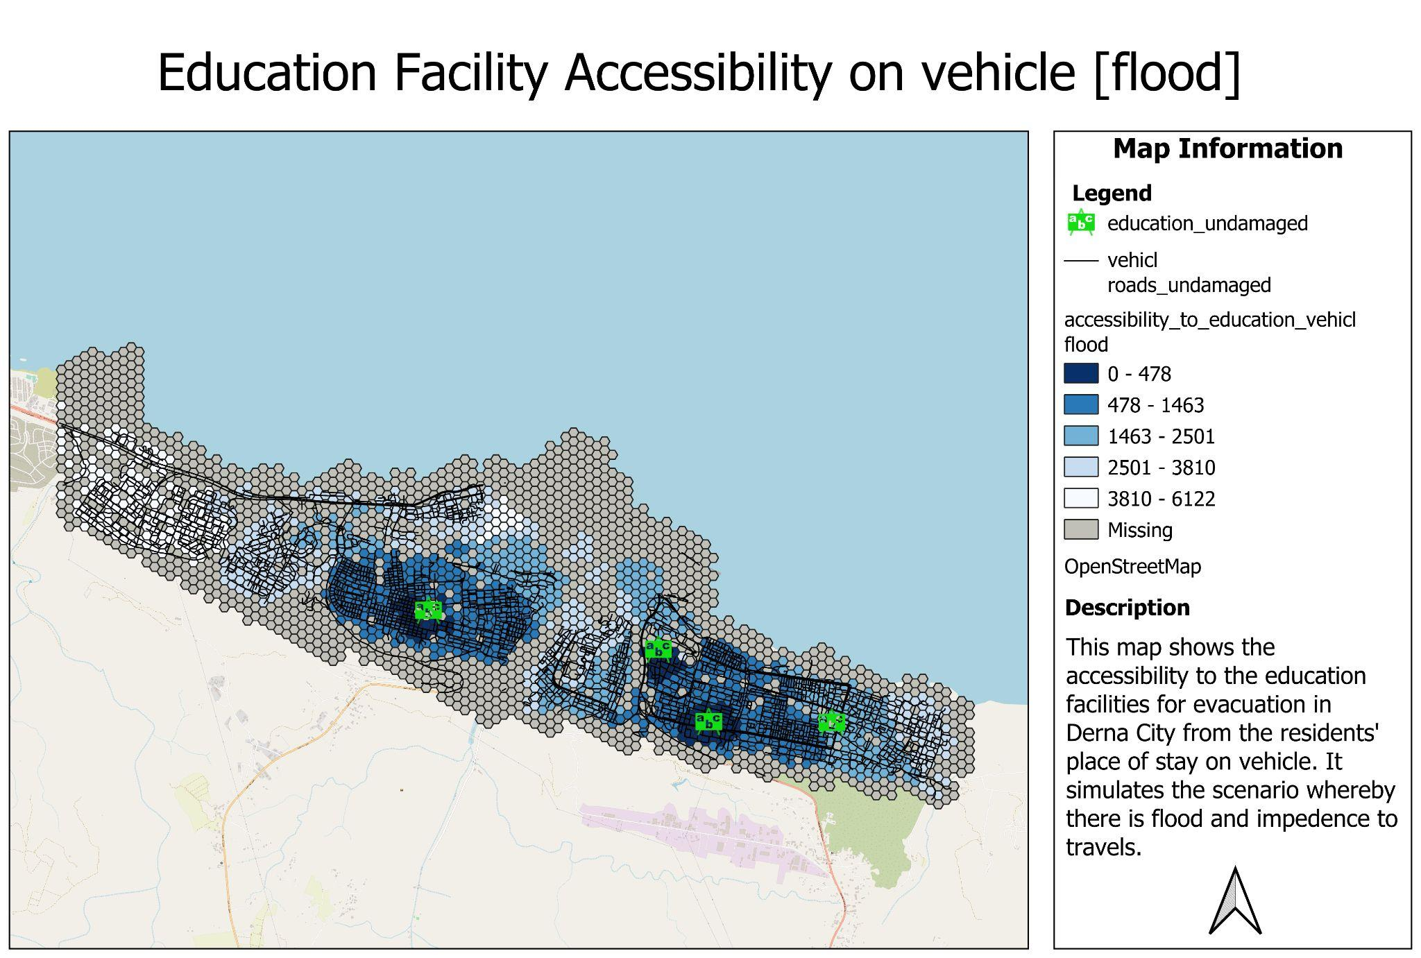

The distribution of education facilities which could potentially act as evacuation centres to host displaced residents is uneven. The West side of Derna City only has 1 education facility that the residents living in that area will most likely congregate at, potentially causing a strain in resources.

As shown by both maps, regardless of the event of a flood, residents living at the far West side have to travel great lengths in order to evacuate the area, assuming that they have a means of vehicle transport. This means that a longer lead time is needed to be given by local disaster detection teams in order for these residents to evacuate to a safe location. However, this may be because the population density in the West side of Derna City is lower than that of other areas. Nonetheless, it still shows that residents living near that area are disadvantaged with regards to evacuation services.

Post-flood, residents living near the coastal area and are most affected by the flood have no road access to any evacuation facilities by the time the flood hits. If no effective flood warning system is put in place with adequate time given to travel to an evacuation centre, the residents might not be able to travel to the next nearest evacuation centre not affected by the flood, at either the West or East side of the city.

The situation might potentially be worsened if residents living or working near the coast during the time of the flood are unaware that the evacuation centre nearest to them is situated in the flood prone area and hence is not suitable as a shelter.

**2D Education on foot**

**No flood Flood**

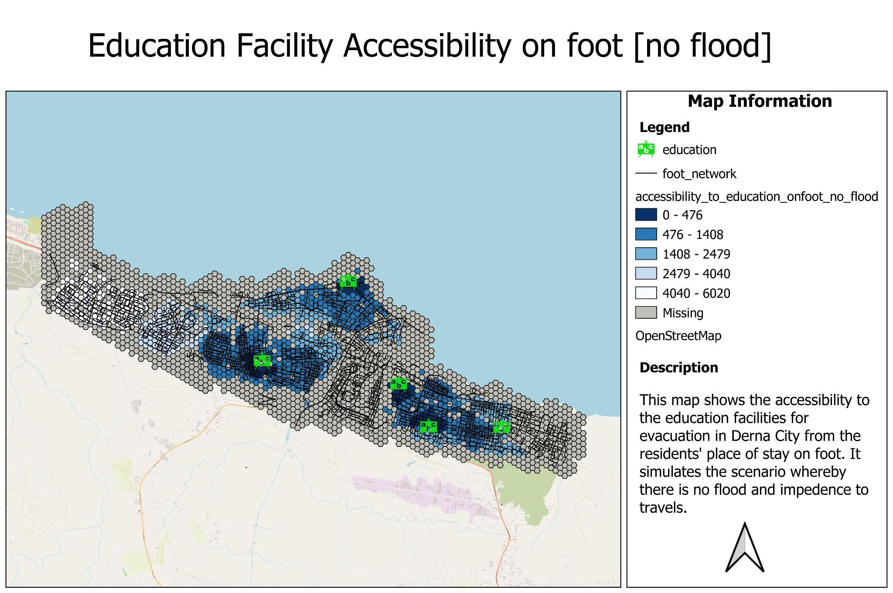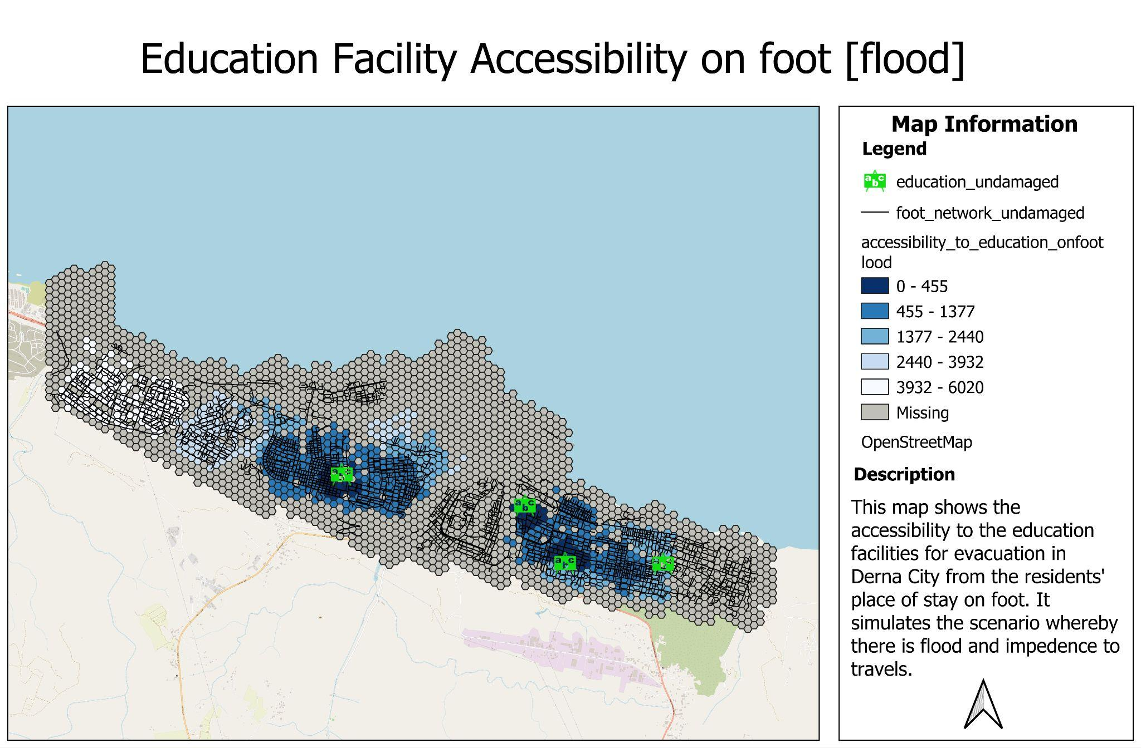

The accessibility to the education facilities on foot shows that when there is no occurrence of flood and movement in Derna is not impeded, the education facilities which serve as evacuation centres are by and large accessible to people. However, for the people who reside near the bridge that connects the west and east side of Derna, their trip to the education facilities might pose some danger as roads there are not completely accessible via foot and consist of large highways.

For the residents living near the West side of Derna, outside the central area, they would have much more difficulty reaching that one education facility as it would take a longer time for them to reach it as compared to travelling there via vehicle. It is concerning that the West residents have such low accessibility to an evacuation site nearby. While a vehicle made it easier for them to travel around despite the long distance, families who are unable to afford a car may not enjoy this privilege. The worst scenario for such residents would be to be shunned away from using the facility due to the lack of vacancies after a long walk.

Post-flood - The second map reflects the aftermath of the flooding in Derna City, where there is one education facility that could serve as shelter for the flood victims but became unavailable as it is submerged within the flood extent. If there were any residents living close to the coastal area who are trying to evacuate, travelling on foot to the nearest evacuation centre could be daunting. Even so, there may not be enough vacancies in the facility as the facility would have to cater to so many residents, especially the ones who lived downstream of the flood in the South.

This is especially bad for families with young children who may not have the ability to walk long distances without assistance. Should they not be able to reach the evacuation centres in time before the flood hits, they may get swept away by the storm.

**Map 3: Service Areas**

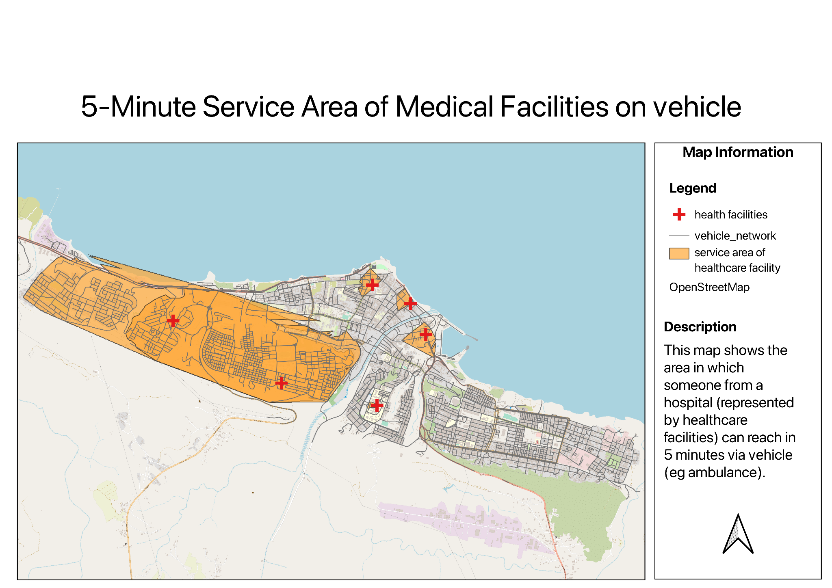

Within the flood extent

From this map, it can be seen that even if the health facilities in the area covered by the flood extent are operating to a certain extent, the response time of ambulance services will be severely delayed, considering the small area the ambulance service can reach within 5 minutes for the areas near the coast. This is because of the high amount of floodwaters or mud present which will greatly impede the speed at which the ambulance can travel at. It should also be noted that in the worst case scenario, it might be completely unsafe for vehicles and hence would deem this area completely inaccessible.

Outside of the flood extent

On the west side of the flood extent, ambulance services are able to cover most of the West area within 5 minutes should there be any emergency considering that most roads will not be affected by flood, and that there are 2 hospital facilities. However, this is severely lacking in the East. A huge area is not covered and that could possibly lead to a delay of medical attention provided to the residents in that area. Given that the Eastern area is highly populated, the delay in medical attention might result in severe repercussions for the victims. The ambulance services may not be able to bring patients to the hospital fast enough to rescue them since they might get impeded by secondary effects of the flood, for example the rest of the highway being inaccessible due to a part being broken, or a bridge being broken, etc.

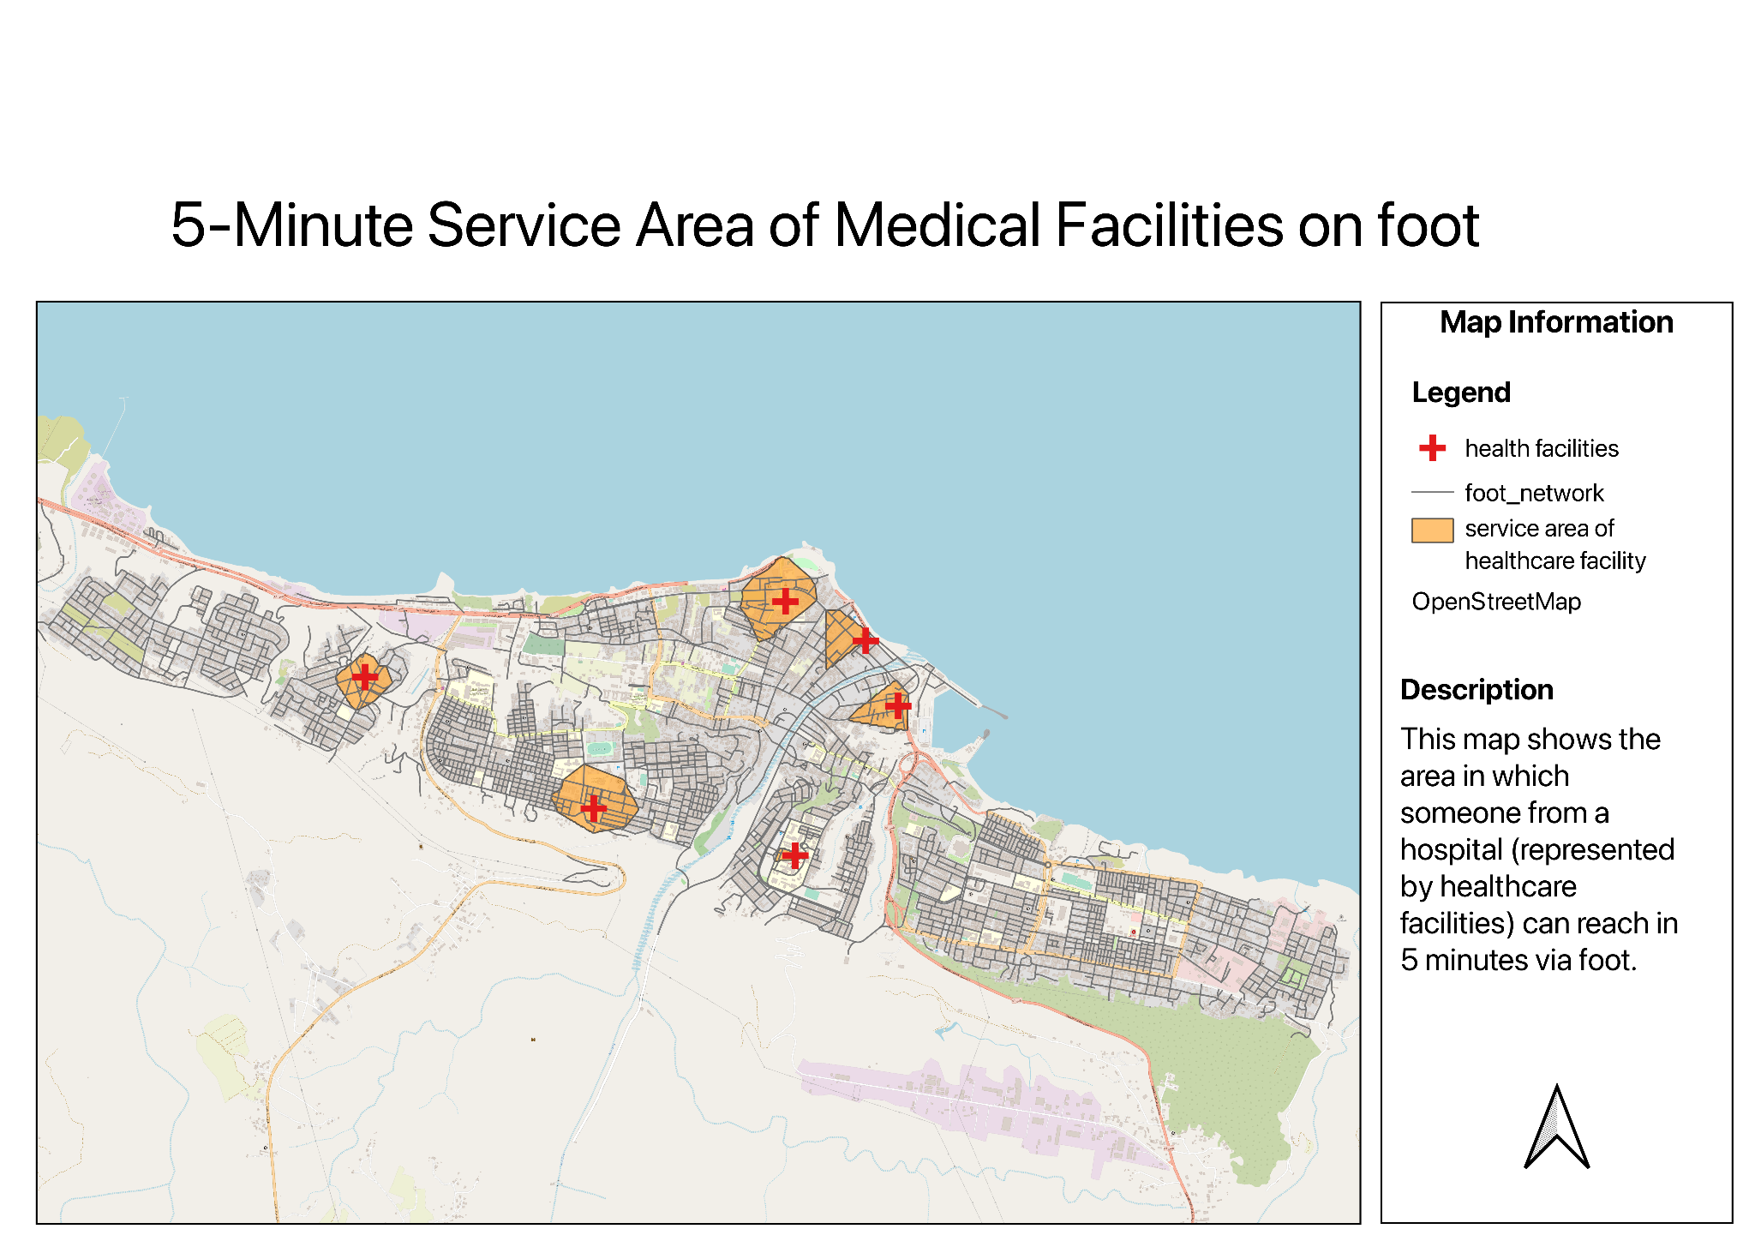

In the worst case scenario, telecommunications may be shut down during a disaster and residents have no way to call for medical attention. They may also not have access to a car. Hence, they may have to resort to travelling to the hospitals by foot in desperation.

Furthermore, hospitals may not have enough ambulances or vehicles to dispatch during a large-scale emergency, and rescue teams may have to find alternative means of travel. This is especially so if the height of flood waters makes it impossible to drive through.

Because of the slow speed, walking is largely impractical during an emergency. This is also shown by the small service area of each hospital by foot. Paramedics may not be able to reach victims fast enough before they get submerged by the flood waters, especially for facilities within the flood extent. This is also based on the assumption that these healthcare facilities can partly withstand the flood.

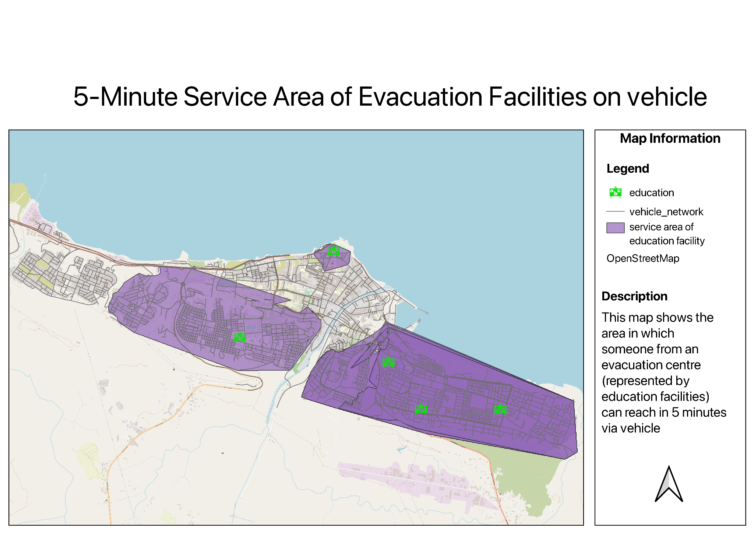

Because of the extensive road network, the service areas of all the evacuation facilities combined together is quite comprehensive and covers quite a large extent outside of the flood extent. The concern might be with regards to the people who are trapped in the flood waters who rescue teams might not be able to reach within 5-minutes, causing them to be swept away and disappear. Furthermore, this is assuming that there are sufficient rescue vehicles to properly serve all the residents. Otherwise, the minimal number of rescue vehicles might mean that several trips have to be taken.

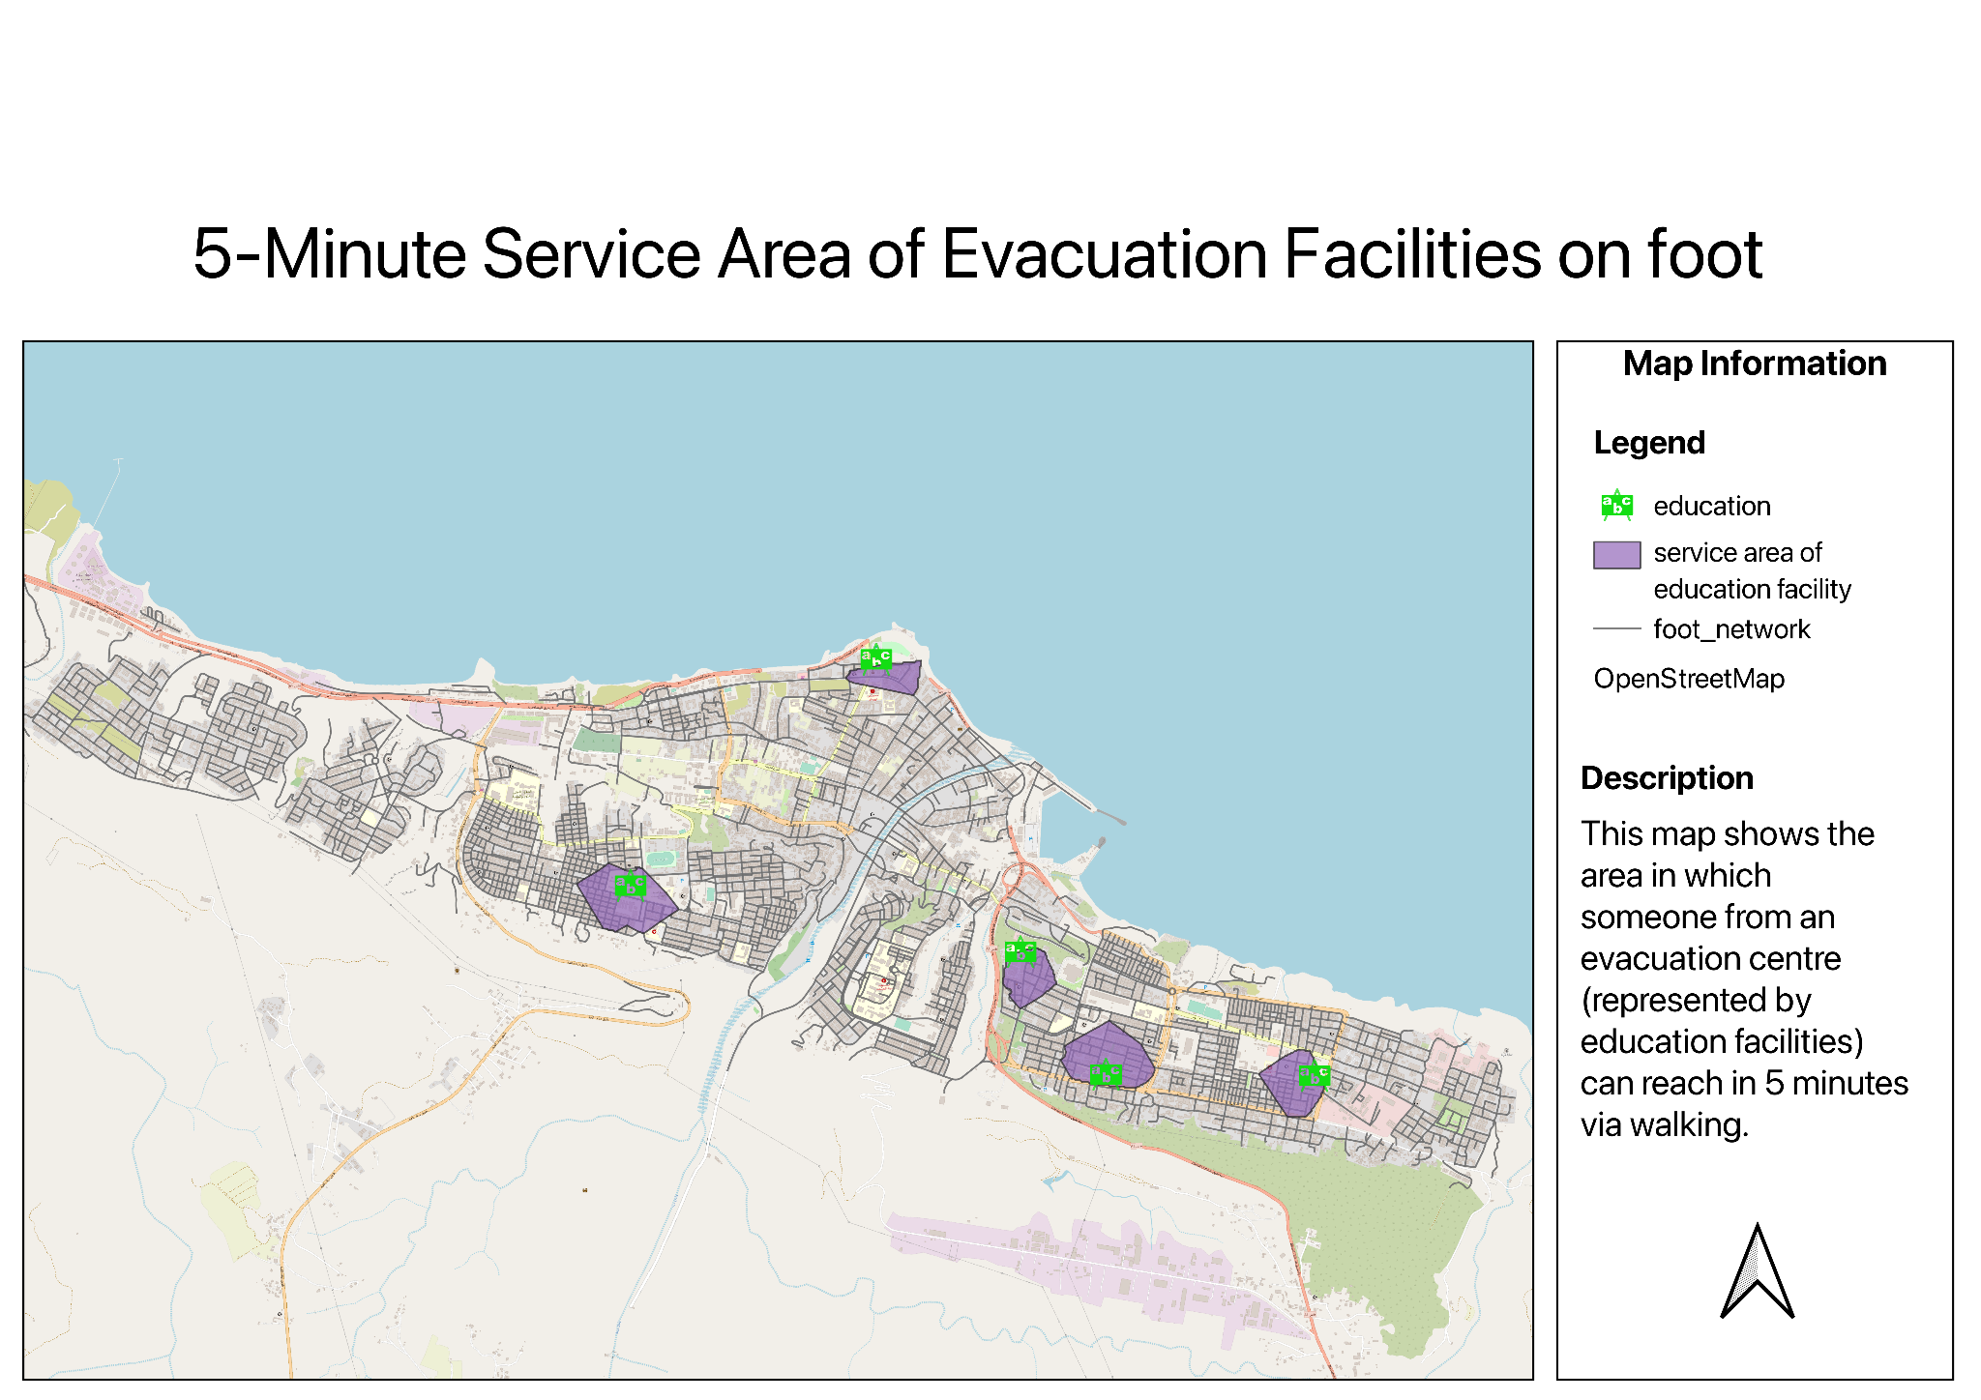

Due to the lack of a well-connected foot network for pedestrians, it is expected that the extend of the outreach from the education facilities within 5 minutes is rather limited.

This will not be a huge concern as most people would be travelling to the education facility to seek shelter and less people would be travelling outwards unless they are fetching some to the shelter. This might however pose a concern for authorities who have to attain resources from other evacuation centres, should one be overcrowded.

# Overall Analysis and Recommendations

Overall, we can conclude that post-flood response and recovery is largely lacking in Derna. This is considering the general poor accessibility to key facilities like healthcare and evacuation as shown in our previous analyses.

Though the road network is extensive and largely sufficient, the issue lies in the facilities themselves. Even during the pre-flood situation, the number of facilities may seem decent, but they are insufficient as seen from our analysis due to the existing facilities’ vulnerability to flood waters. Healthcare and education facilities need to be increased especially for areas outside the flood extent so as to ensure that survivors can be directed and have their needs met, reducing the amount of casualties. As a side note, perhaps roads could be constructed to serve both vehicles and pedestrians alike, improving the accessibility, should an alternative mode of transportation ought to be taken.

This is especially in terms of walkability and accessibility via foot. During a disaster, vehicles may be inaccessible and residents may have no choice but resort to walking. However, this meant reduced accessibility as hospitals and evacuation facilities are well beyond walking distance. Even if rescue teams are dispatched, their reach is limited because of the location of the small number of facilities and may not be able to reach the residents in time. In disasters like these, time is of the essence.

We find it important to analyse the accessibility of vehicles in terms of walking as well because residents may be swept away to areas far from their homes with no access to their vehicles during a catastrophic flooding event. As a secondary effect, there may be a disruption of other services, such as internet connectivity and telecommunications. This may impede citizens’ ability to contact the relevant authorities, such as ambulance services and rescue services, leaving them little choice but to make their way to the healthcare and evacuation centres themselves without the ability to use a vehicle. However, since Derna City’s terrain is mostly sandy, authorities’ help is crucial in ensuring the safety of the victims on the journey to these facilities as well. However, if the rescue teams are unable to get there fast enough, the Derna residents’ lives will be endangered.

Other modes of emergency transportation, such as ambulance boats, or helicopters to transport resources like food and clean water, needs to be explored to prepare for the worst scenario where roads are completely destroyed and inaccessible.

Additionally, an even spread of facilities is needed so that each part of the city is sufficiently covered. Though it might make sense to concentrate facilities where the population density is higher, doing this would cause an over-dependency of the facilities in the specific area, in this case, most prominently the central area. As illustrated in this case, when disaster hits, these facilities may very well be destroyed. Spreading the locations of the facilities would mitigate this risk, and also ensure that each facility has sufficient vacancies, which would also tackle the issue of overcrowding in times of need with a concentration of residents who flock to that facility since it is the only one nearby. Rather, if facilities are in reasonable proximity to each other, less-urgent cases could be redirected so as to effectively spread out resources. Other than education facilities, other facilities could be built and repurposed as evacuation shelters, such as sports halls or indoor stadiums.

From our analysis, given the current situation and geography of post-flood services and amenities, there is a great need for rescue teams to supplement the sparse infrastructure in place and effectively assist the citizens. Perhaps one of the ways to do this is to set up temporary man-made shelters or leverage other facilities to serve as shelters for victims to reside in. They should set these up in areas near the flood extent, yet not too far away in order to make it accessible. Other long-term recommendations will be explored further in later sections.

However, the truth is that due to the lack of resources that Libya has as a nation, there are unlikely to be rescue teams sent out in such a short period of time. Libya relies heavily on international aid and humanitarian efforts from other countries to help victims of floods. However, the countries closest to Libya– Egypt and Tunisia– are not the wealthiest.

Looking at the big picture, it should also be noted that, unlike other well-developed cities like ones in the US, there are no nearby urban areas that citizens can evacuate to. This is because Derna’s surroundings are on one side the coast, and the other side, the desert.

# Limitations of project

Our project has several limitations. They are mainly concerned with the availability and accuracy of data.

Upon inspecting the initial data downloaded from the open-source site Humanitarian Data Exchange, we noticed that there might be missing data points. Hence, we sought to correct them through comparison with other sources of data.

As a complement to accessibility analysis, we were unable to gather data about the availability of resources that each healthcare facility had, i.e number of medical staff, amount of vacancies/hospital beds. This applies to evacuation shelters as well, as we do not know the capacity of each school. Certain schools may differ greatly in its capacity and hence affect its ability to allow citizens to vacate to that area. This might impede a resident’s needs from being met if they are turned down by a medical facility or evacuation centre due to the lack of resources and to prevent overcrowding.

Perhaps an analysis concerning the capacity of these facilities would allow our analysis to be more comprehensive.

# Future work

Our project has focused on the recovery and response aspects of flood management, but disaster management consists of four phases– preparedness, mitigation, response and recovery. Hence, to ensure a holistic and effective approach towards flood management, work could be expanded to cover these areas as well.

Preparedness

Based on our current analysis, it is based on the flood that happened recently. However, the flood extent could differ in the future. The history of floods could be studied via historical data and topographic data so as to predict flood frequency in Derna. More detailed hazard mapping could also be done to show areas expected to be covered with floodwaters for various situations. To complement the work of urban planners, sufficient sensor technology and infrastructure that warns the residents of incoming disasters can be employed. Ideally, the authorities could use existing communication networks and deploy manpower to evacuate people to safety when a warning is issued.

Mitigation

We recommend that the authorities should improve on their mitigation strategies because it will have a knock-on effect on response and recovery efforts, in terms of accessibility. Specifically, it is vital to ensure that infrastructure can withstand the floodwaters. Building codes and standards need to be enforced for structures within the floodplain. They must be engineered to withstand the high velocity of flood waters and are high enough off the ground to reduce the risk of contact with water. This can be extended to other disasters, such as earthquakes. Authorities should reinforce the infrastructure of key facilities such as healthcare facilities and places that could act as evacuation centres. However, because of the conflict in Libya, it might be difficult for this to be effectively implemented, and the Libyan authorities might not deem this a priority.

As mentioned, the flood is caused by the collapse of the dams. While the construction of dams may be able to prevent flooding, it may backfire as seen in this case. Hence, authorities need to constantly monitor the condition of the dam and ensure that it is built adequately. According to BBC, it was said that even though the local institutions and government were aware of the poorly maintained and built dams which could potentially pose danger to the citizens, they did not put in sufficient effort to intervene and prevent disasters that could possibly happen, resulting in the deaths of thousands of people.

As a coastal city and to prepare for other types of disasters (eg. tsunami) which may originate from the sea and coastal area instead of the river upstream, there could also be hard engineering measures such as the building of sea walls.

Response and Recovery

Other than that, there has to be sufficient education towards people and authorities about flood disaster evacuation. As shown from our analysis, there could be a lack of awareness among the residents, and as a result, healthcare facilities and education facilities became destroyed and unavailable.

According to a BBC report, it was reported that the evacuation efforts in Derna City were lacklustre. Even though there was help to assist in the evacuation, there was no clear list of areas to evacuate to nor directions . Furthermore, there were people who lived near the river bodies but were told to stay at home and even more worryingly, there were people who had been evacuated to dangerous places that fell within the flood extent. This placed them in life-endangering situations.

Work could be done to map out possible evacuation routes for citizens from hotspots where people mostly gather (e.g. shopping centres). This will aid citizens in having greater awareness. Aside from that, flooding may also bring about secondary effects such as the breakdown of communication services and water pollution. Hence, work could also be done to investigate the water and electrical systems in Derna to predict the possible impact and hence explore measures.